## Date : 19 November 2022

**Project Title : Classification of Arrhythmia by Using Deep Learning with 2-D ECG Spectral Image Representation**

## Team Id : PNT2022TMID30495

Image Preprocessing:

Image Pre-processing includes the following main tasks

1. Import ImageDataGenerator Library
2. Configure ImageDataGenerator Class
3. Apply ImageDataGenerator functionality to the trainset and testset

# Import ImageDataGenerator Library:

Image data augmentation is a technique that can be used to artificially expand the size of a training dataset by creating modified versions of images in the dataset.

The Keras deep learning neural network library provides the capability to fit models using image data augmentation via the ImageDataGenerator class.

# Configure ImageDataGenerator Class:

There are five main types of data augmentation techniques for image data, specifically:

1. Image shifts via the width_shift_range and height_shift_range arguments.
2. Image flips via the horizontal_flip and vertical_flip arguments.
3. Image rotates via the rotation_range argument.
4. Image brightness via the brightness_range argument.
5. Image zooms via the zoom_range argument.

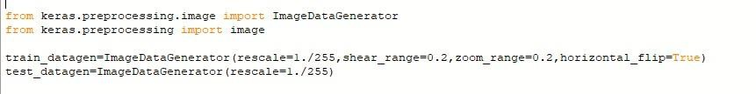

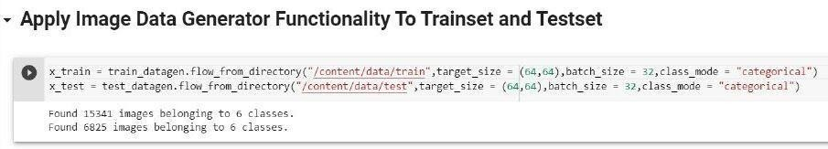

An instance of the ImageDataGenerator class can be constructed for train and test.

# Apply ImageDataGenerator functionality to the trainset and testset:

We will apply ImageDataGenerator functionality to Trainset and Testset by using the following code.

This function will return batches of images from the subdirectories Left Bundle Branch Block, Normal, Premature Atrial Contraction, Premature Ventricular Contractions, Right Bundle Branch Block and Ventricular Fibrillation, together with

labels 0 to 5

{'Left Bundle Branch Block': 0, 'Normal': 1, 'Premature Atrial Contraction': 2, 'Premature Ventricular Contractions': 3, 'Right Bundle Branch Block': 4, 'Ventricular Fibrillation': 5}

We can see that for training there are 15341 images belonging to 6 classes and for testing there are 6825 images belonging to 6 classes.